### goal Nama: Tiwouw, Joseph Janone

1. **Linux Basic**

### LIST OF ACTIVITIES

|  | **Activities** |
| --- | --- |
| **1.** | Install Linux on Virtual Box |
| **2.** | Try basic command and describe the output |
| **3.** | Create, edit, delete file |
| **4.** | Create, delete directory |
| **6.** | Screen shot your SSH |

* 1. **Screen shoot your linux desktop below**

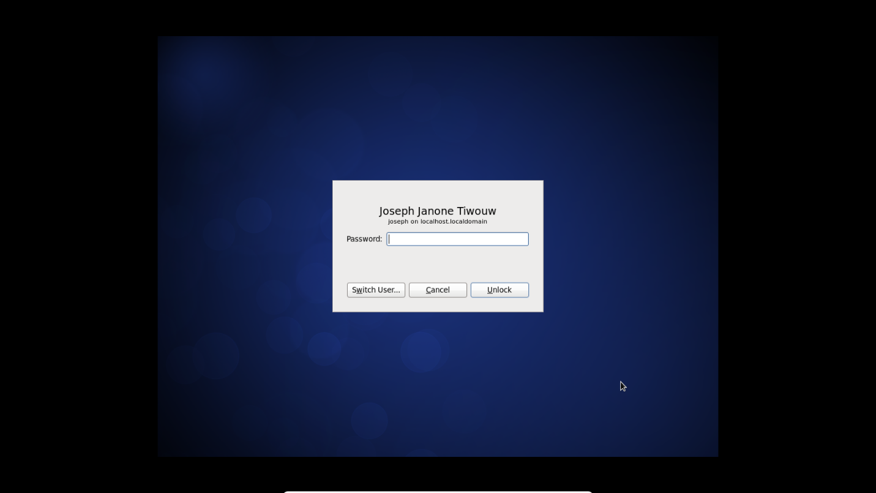

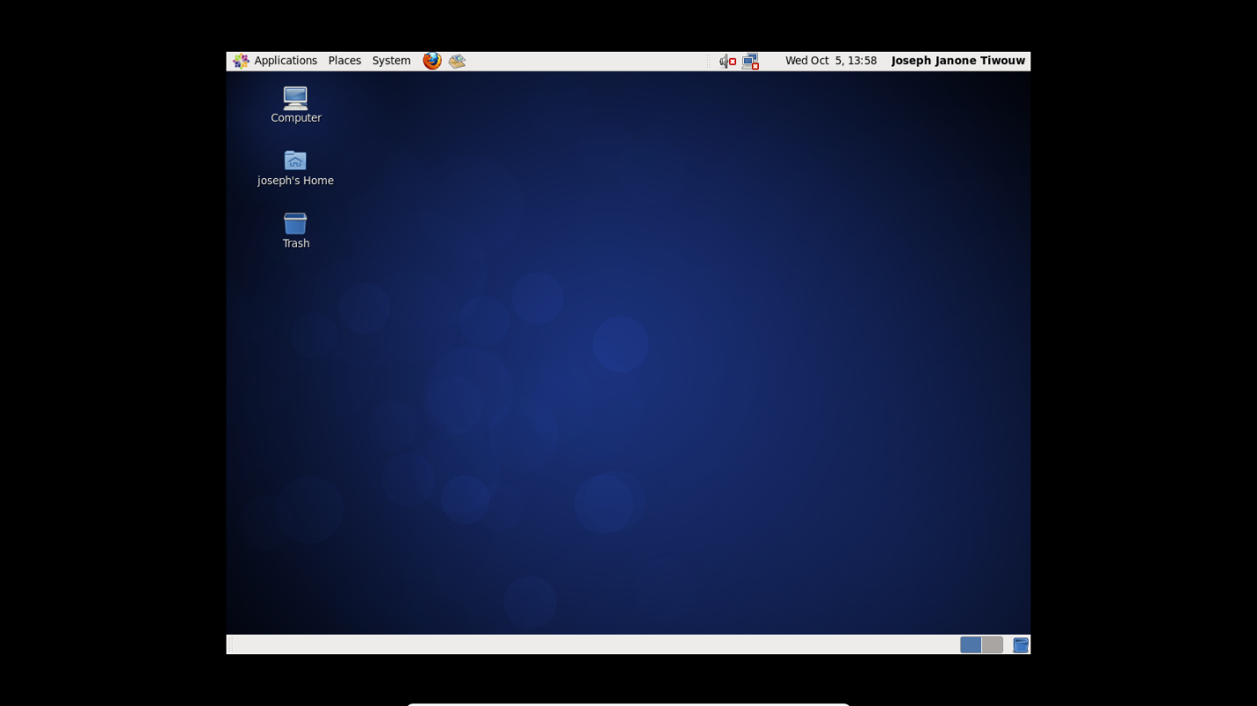

* 1. **Basic Command**

*If you want to learn the command, just type “**man** *command*”

* pwd

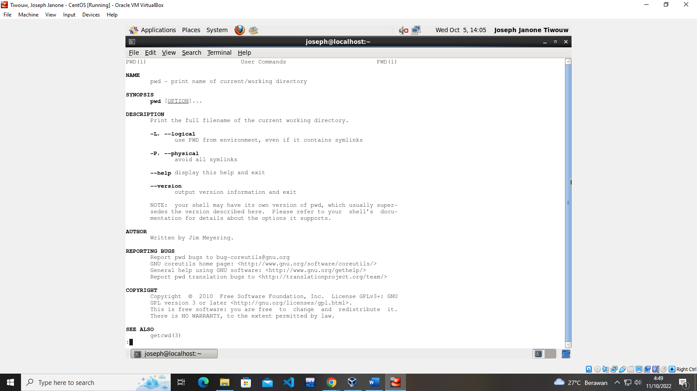

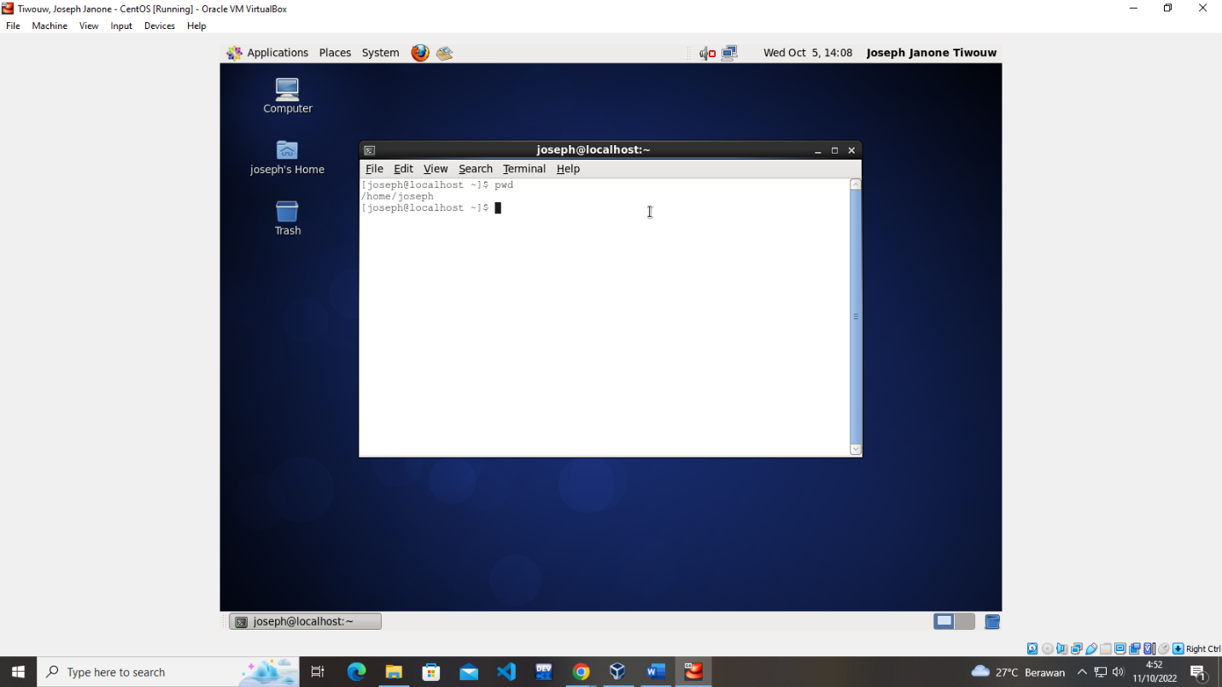

* cd

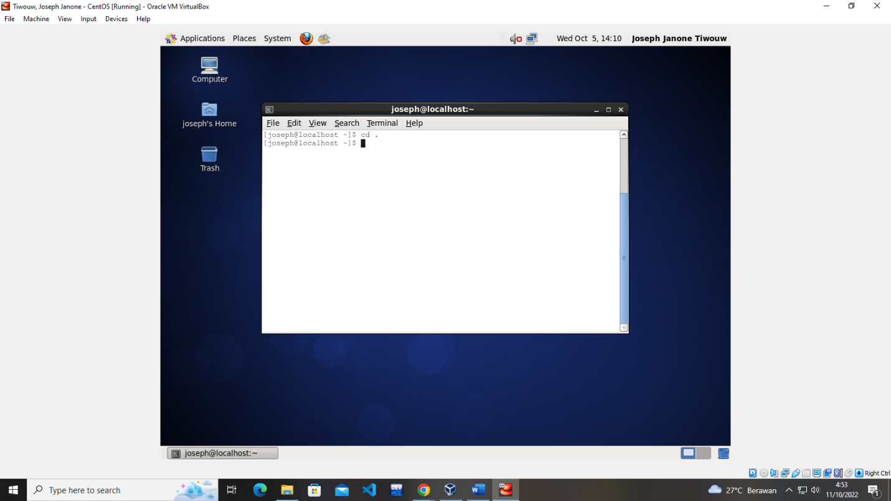

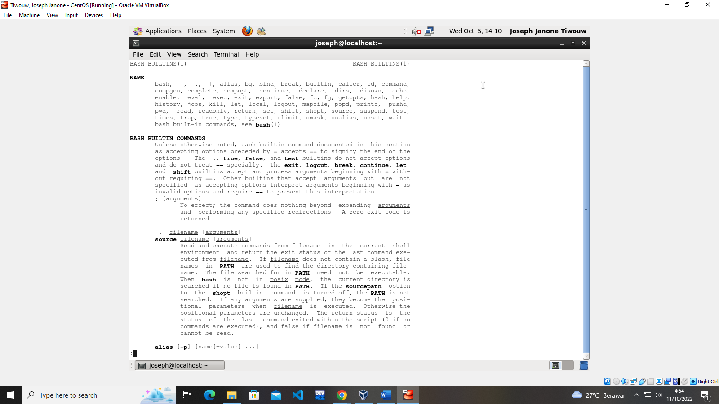

* ls

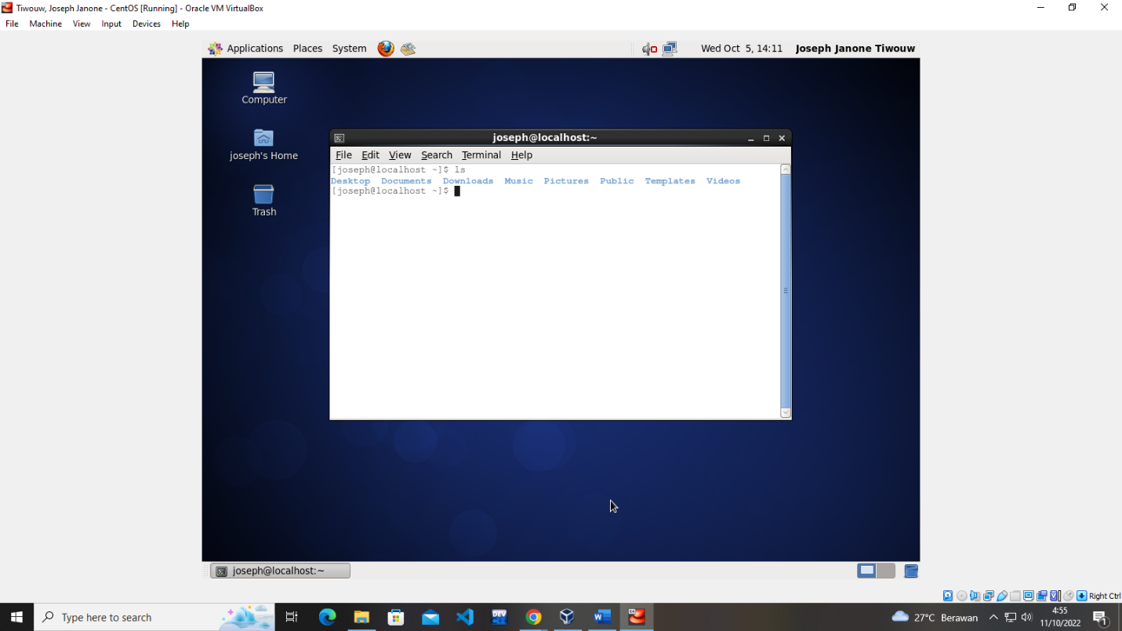

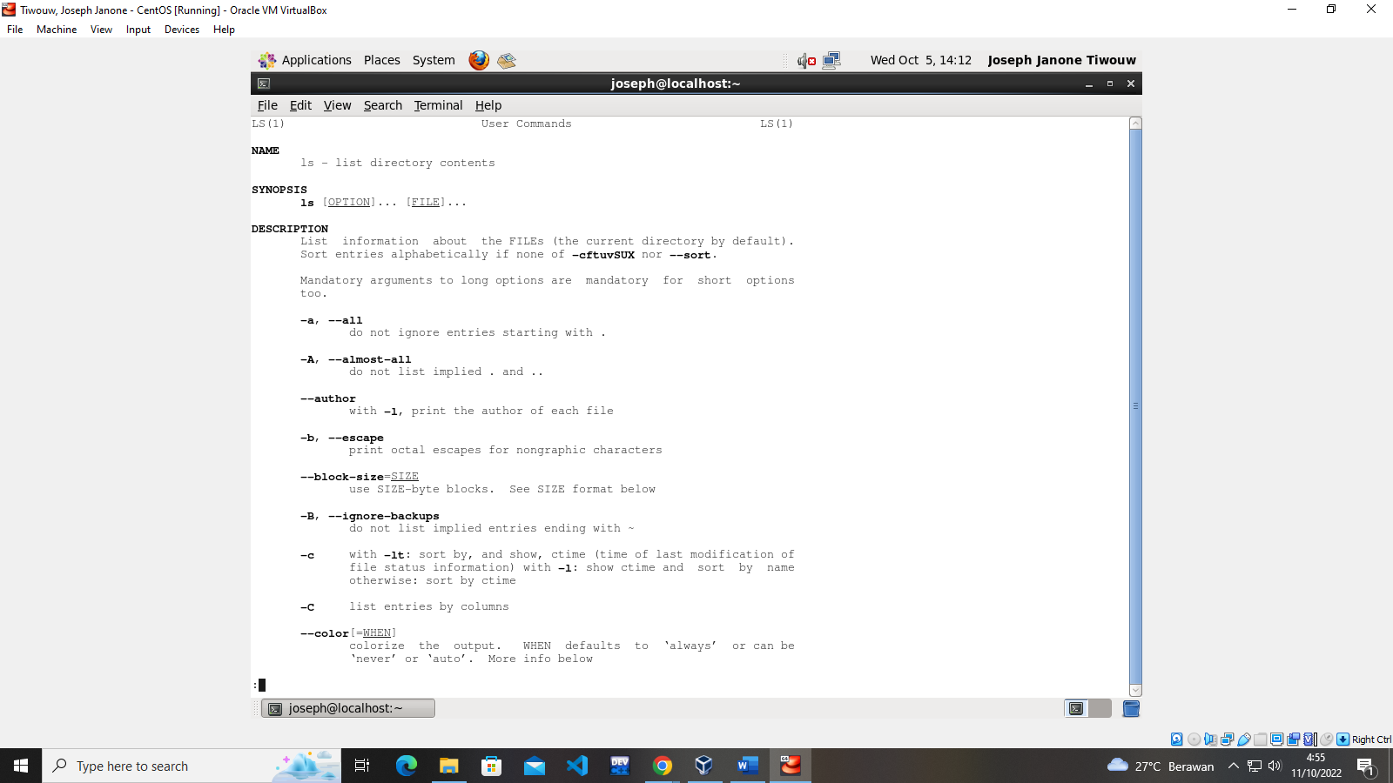

* cat

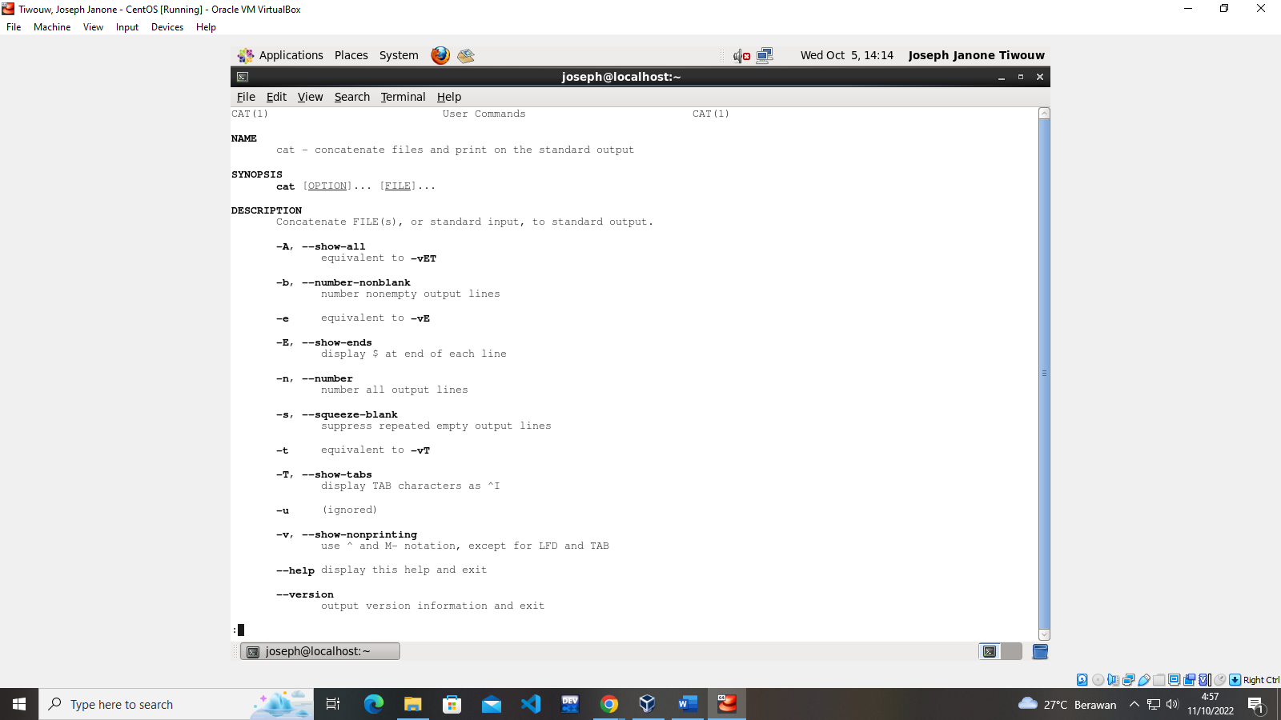

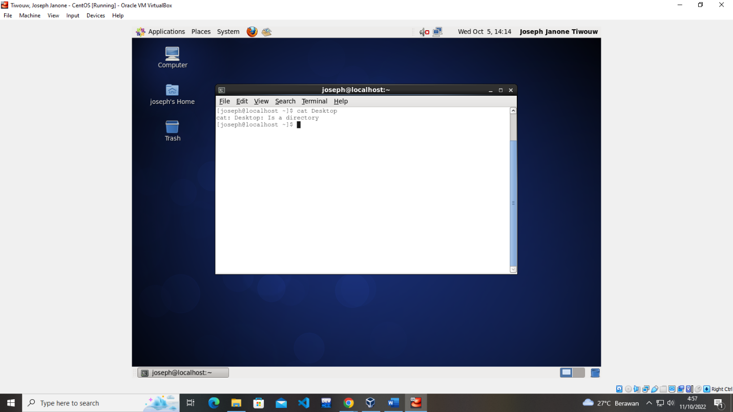

* clear

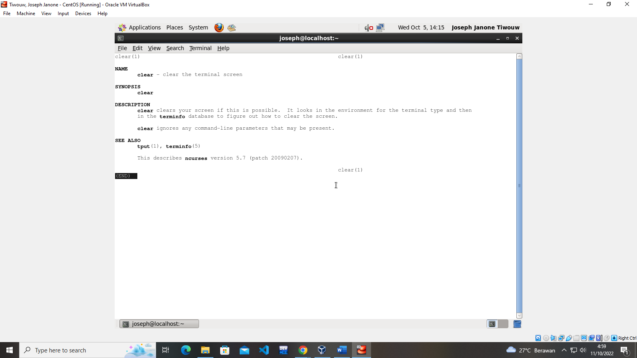

* shutdown

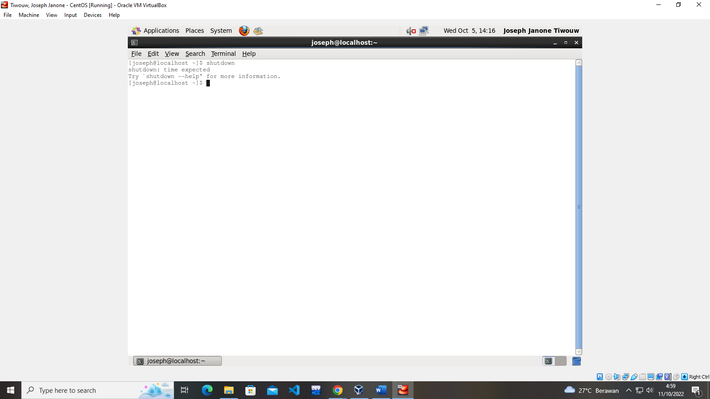

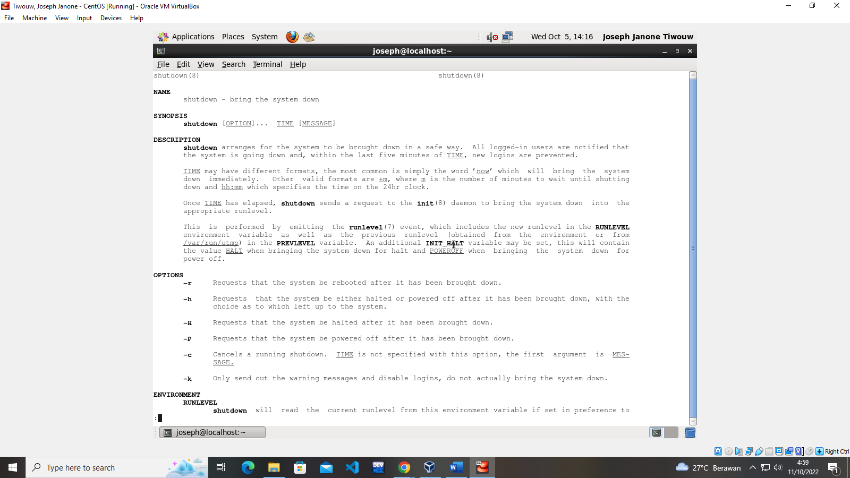

* reboot

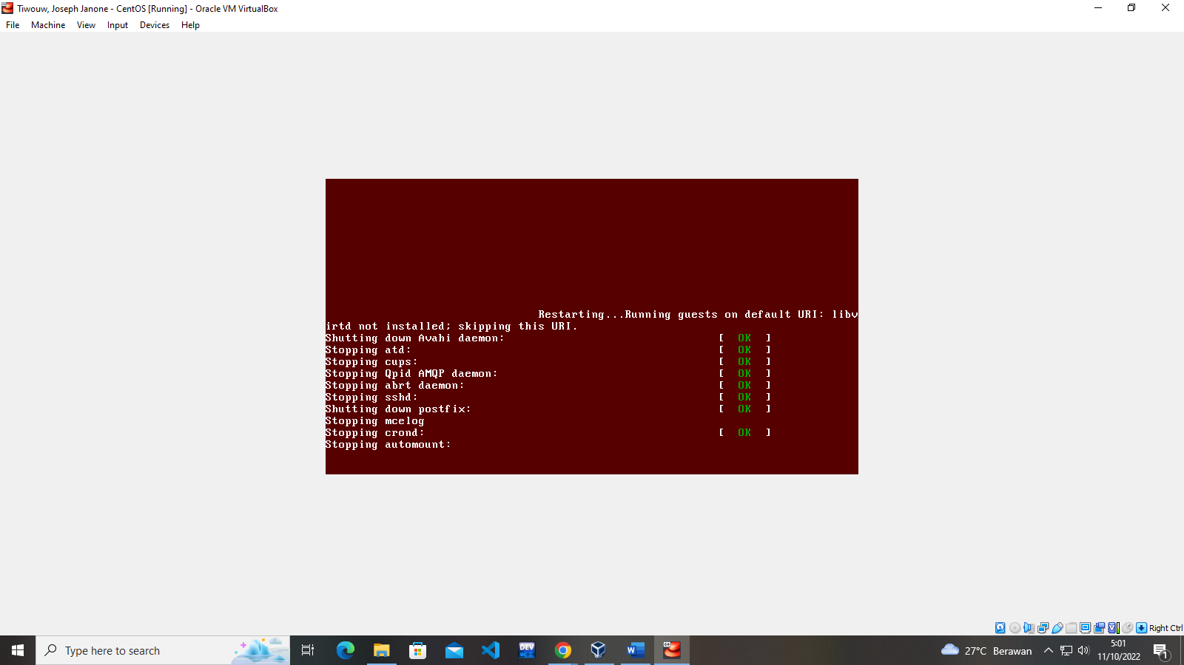

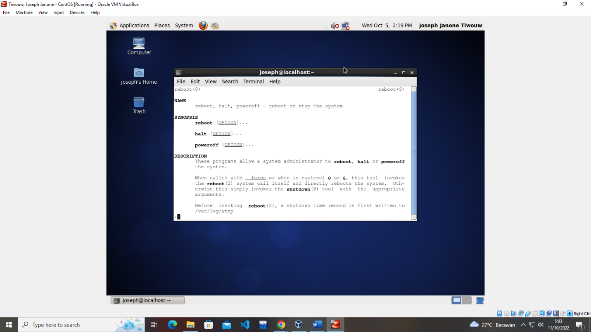

* service

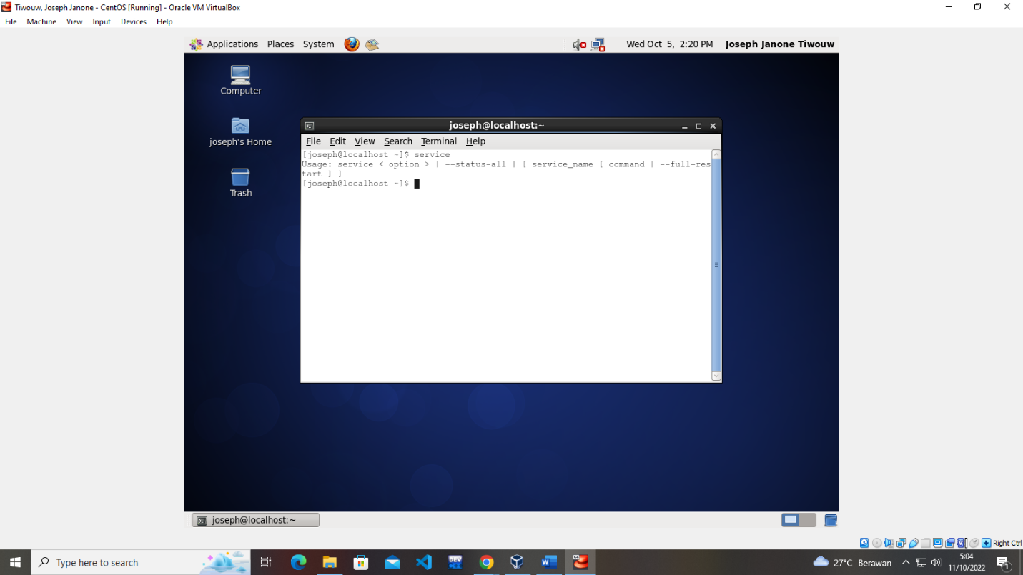

* top

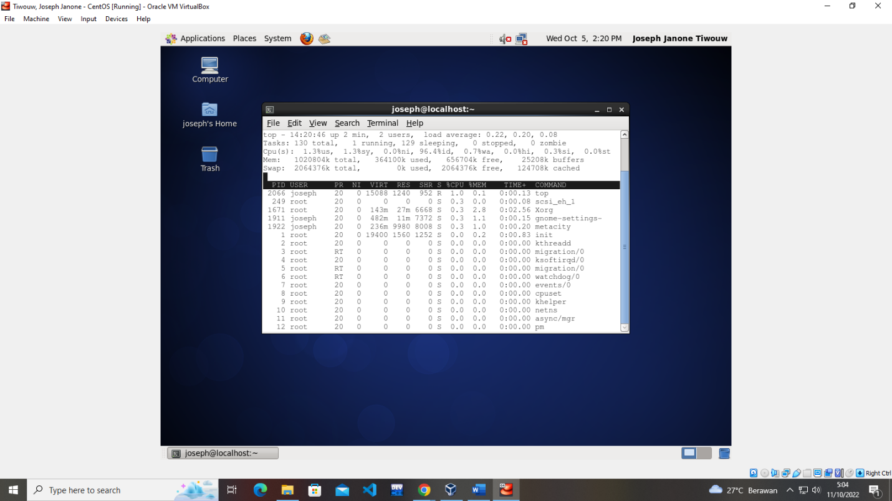

* df

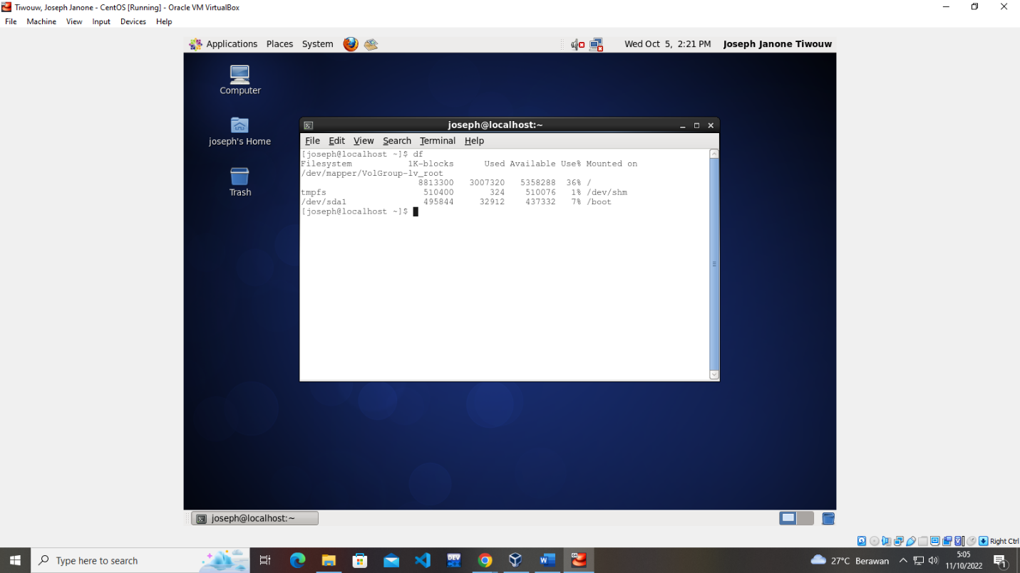

* du

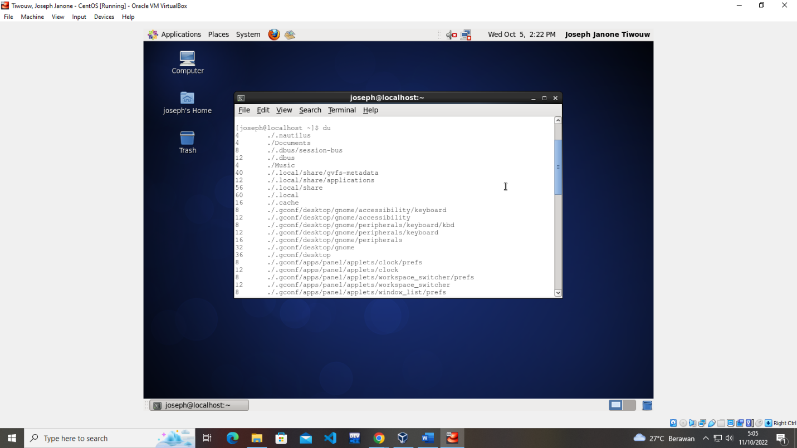

* rm

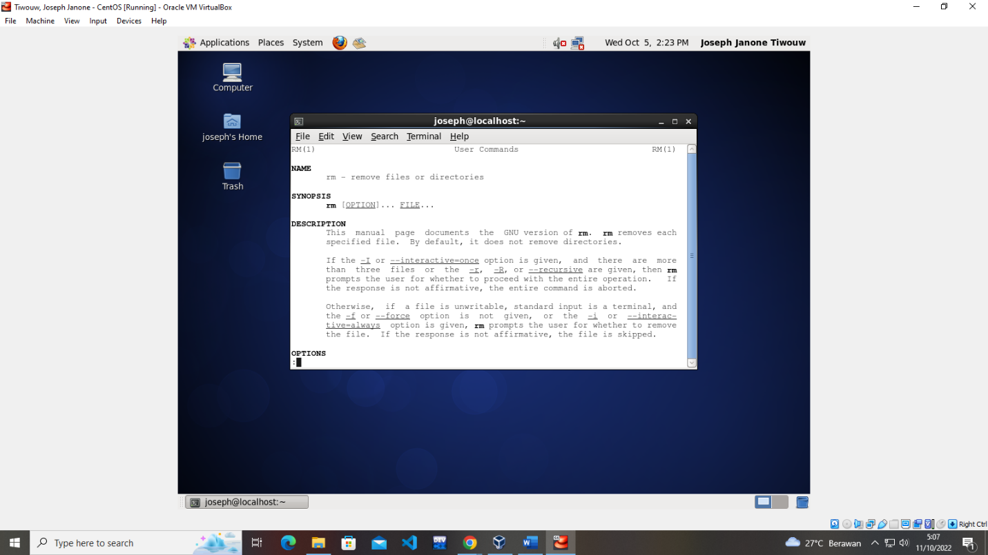

* cp

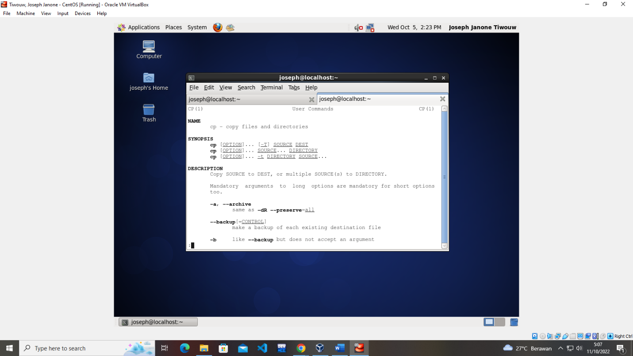

* mv

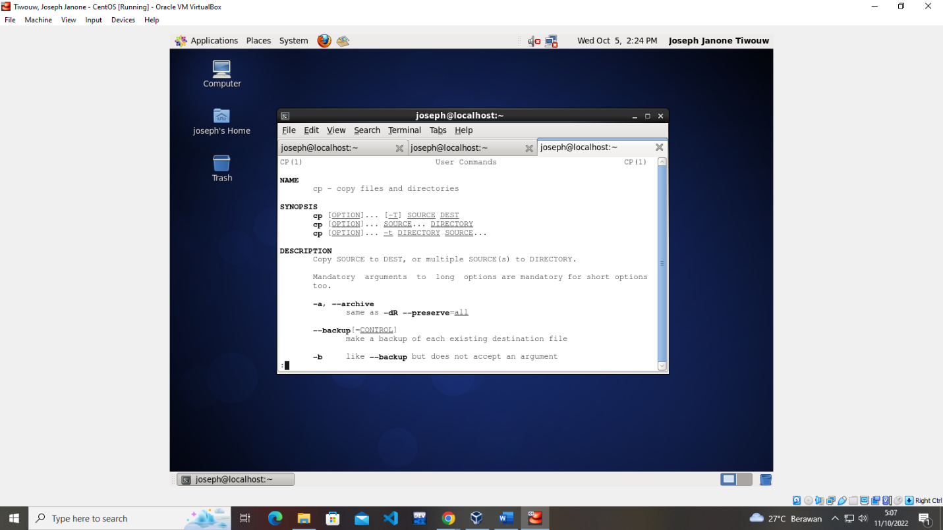

* man

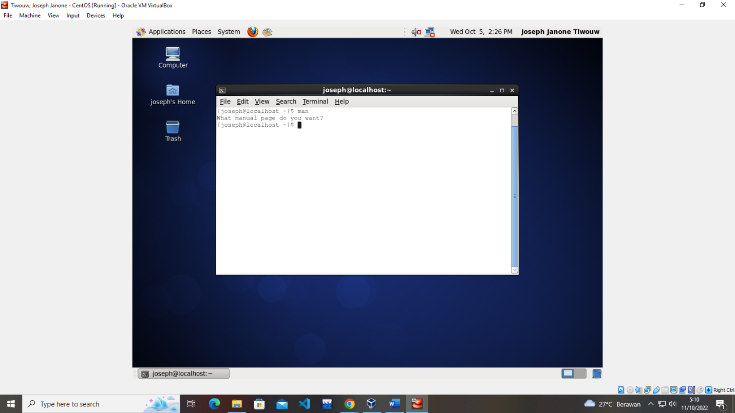

* mount

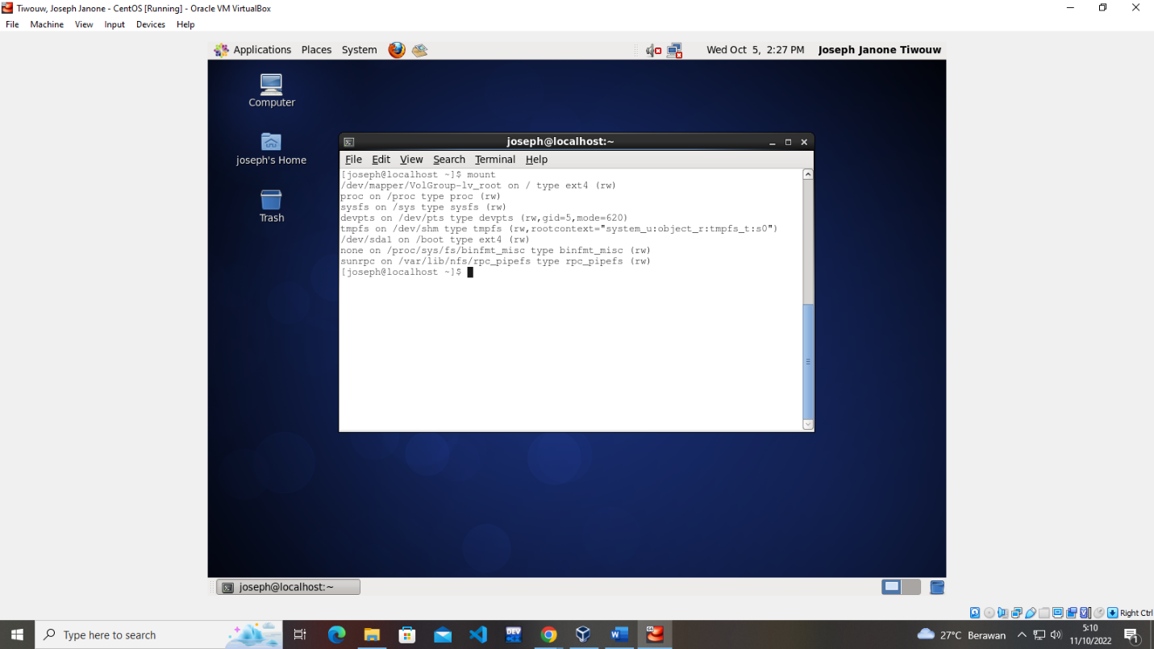

* mkdir

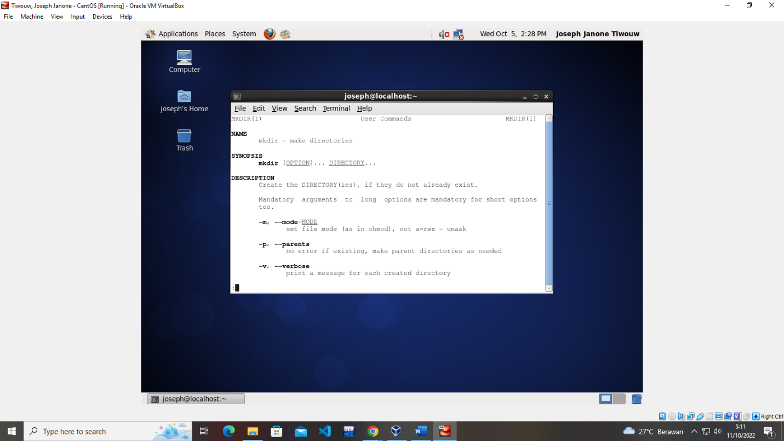

* passwd

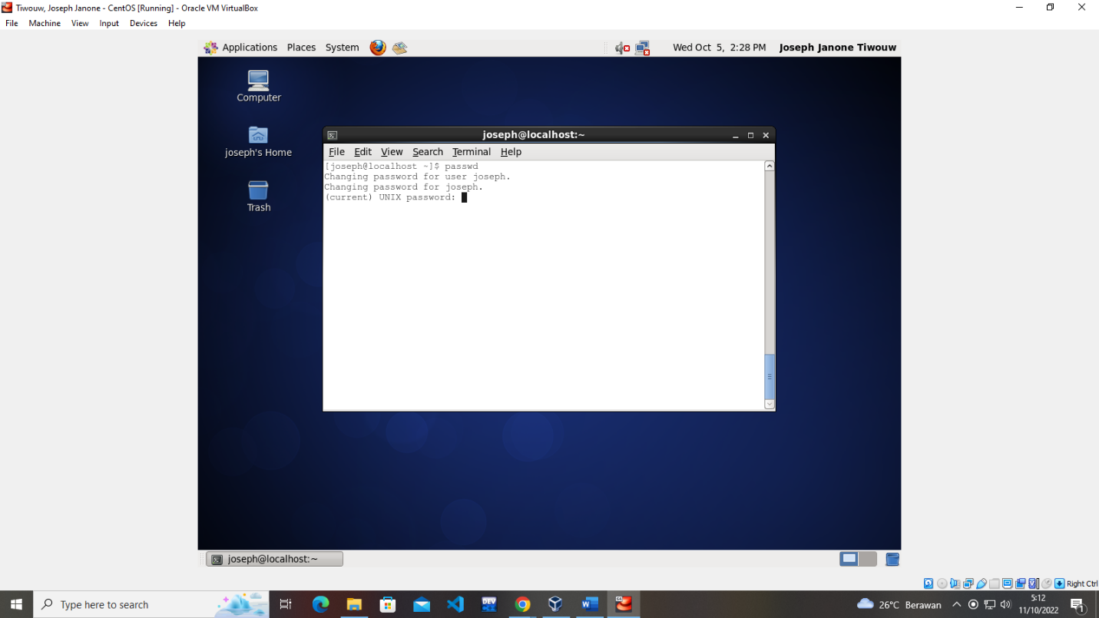

* ifconfig

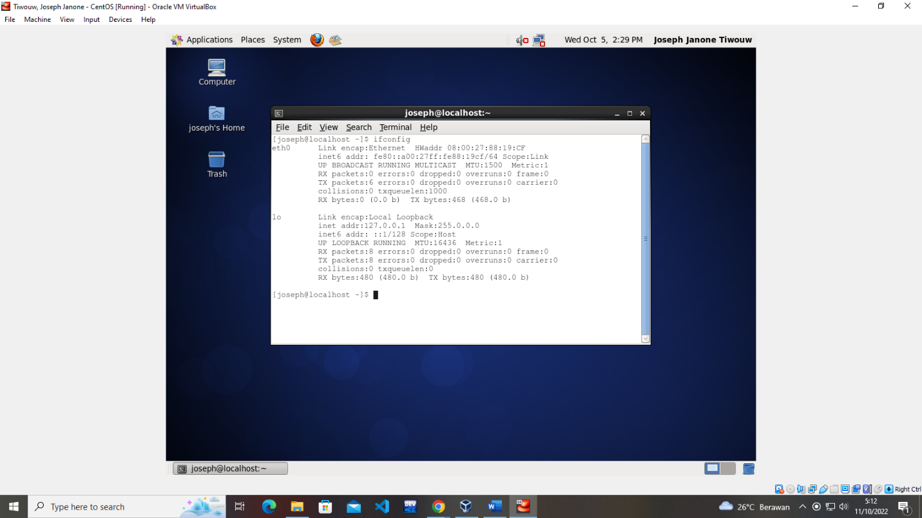

* locate

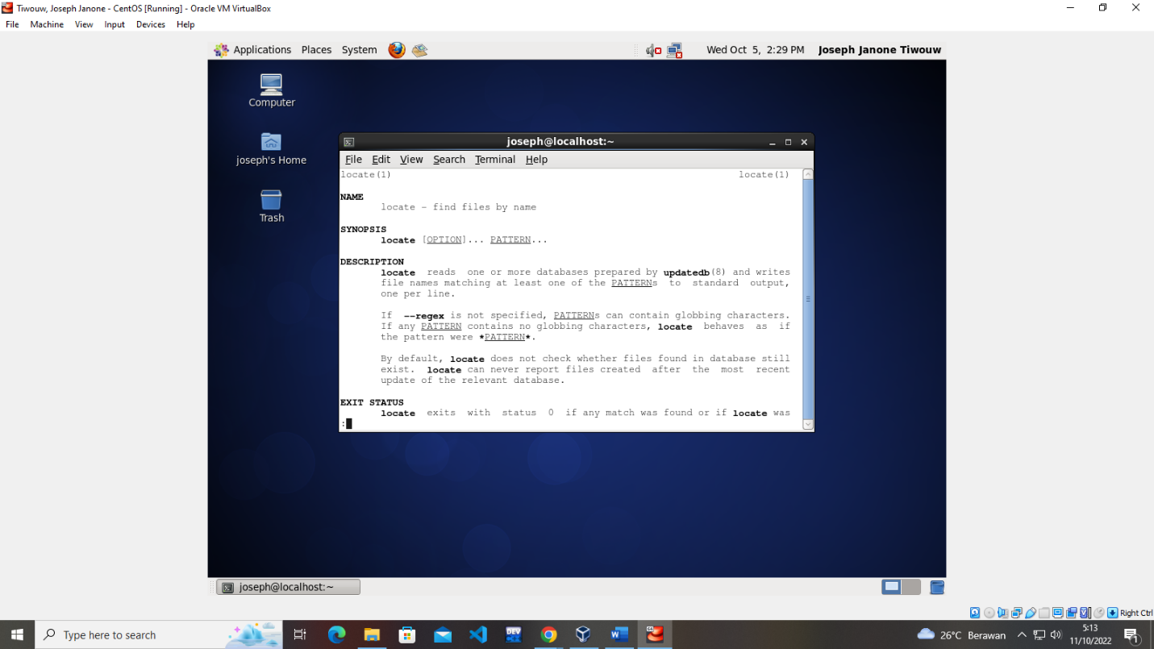

* su

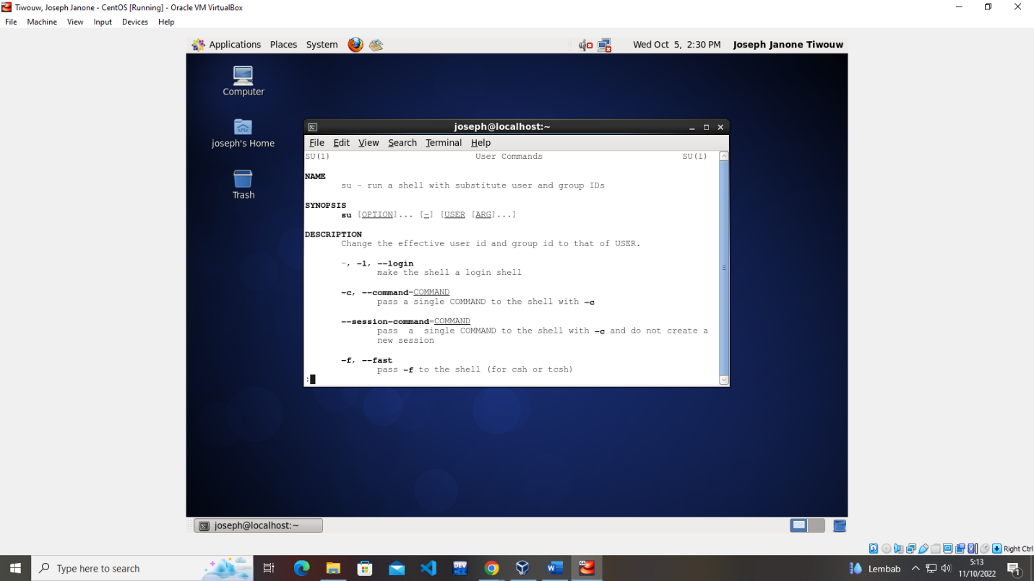

* ping

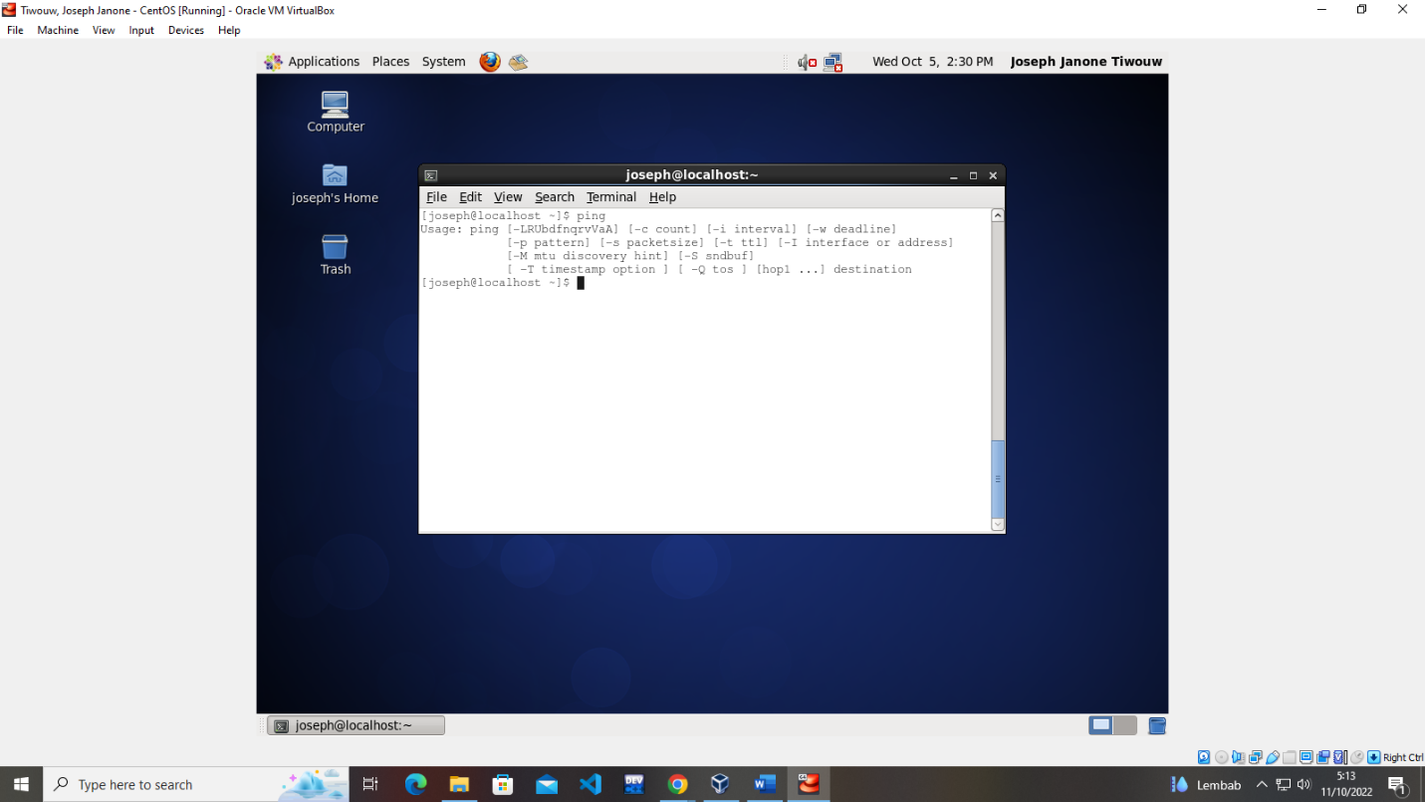

* date

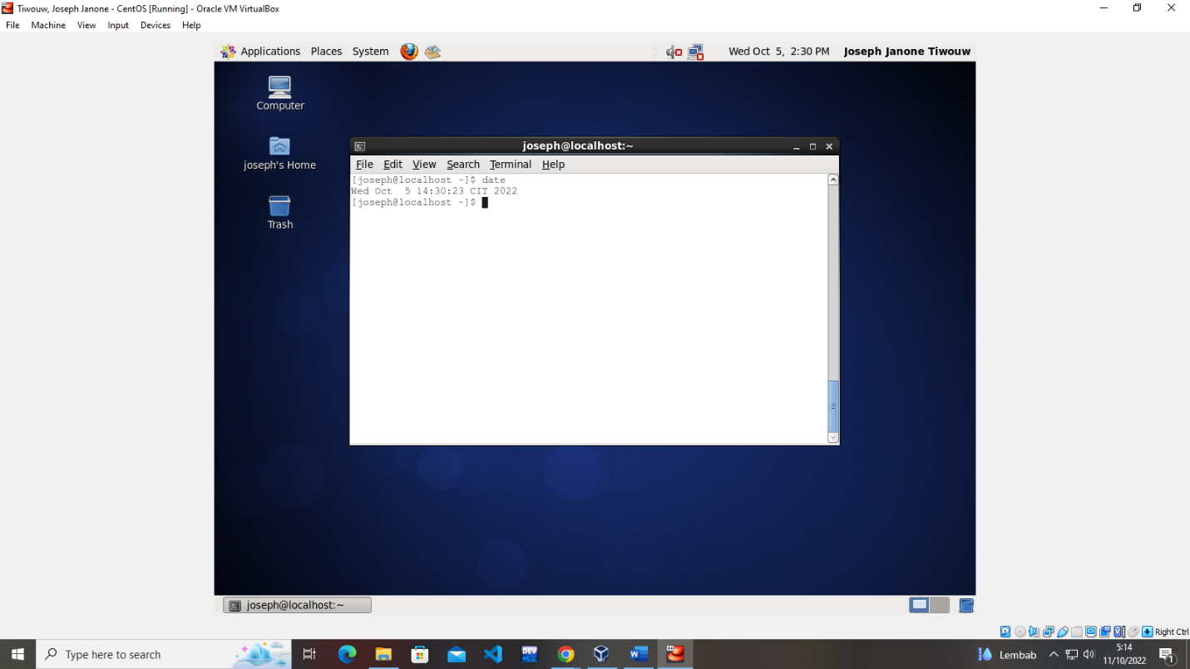

* touch

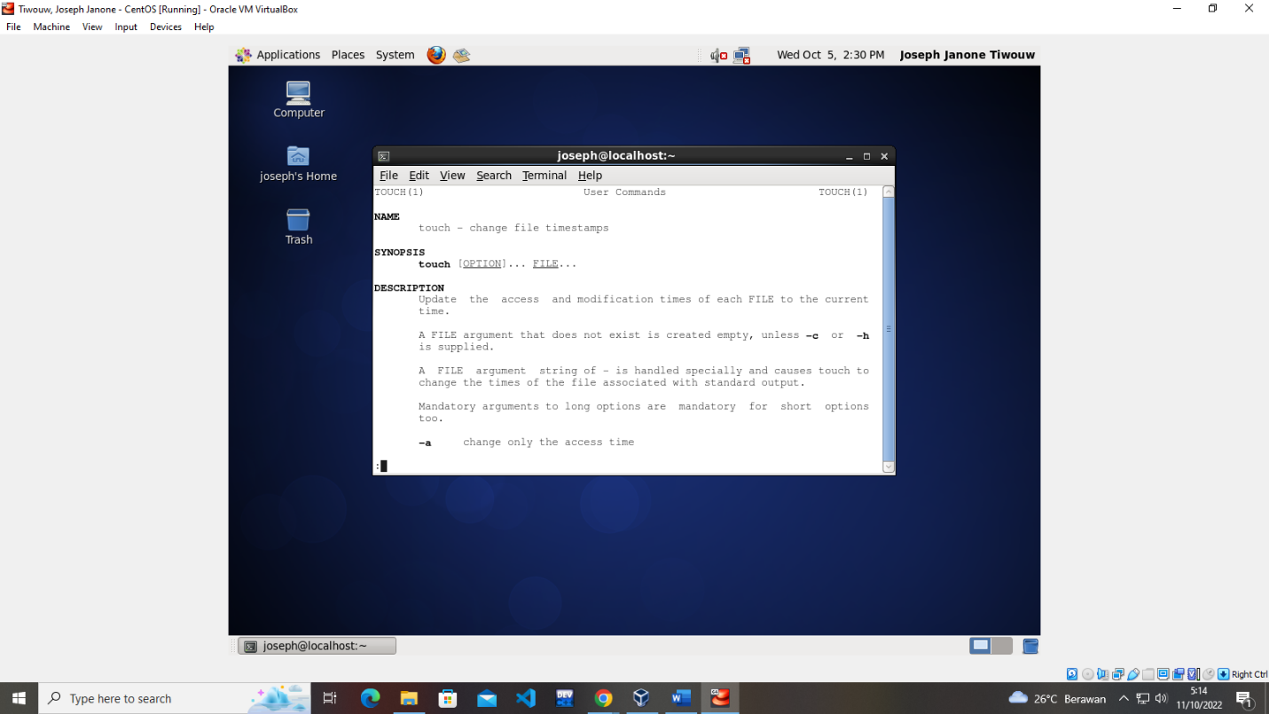

* vi

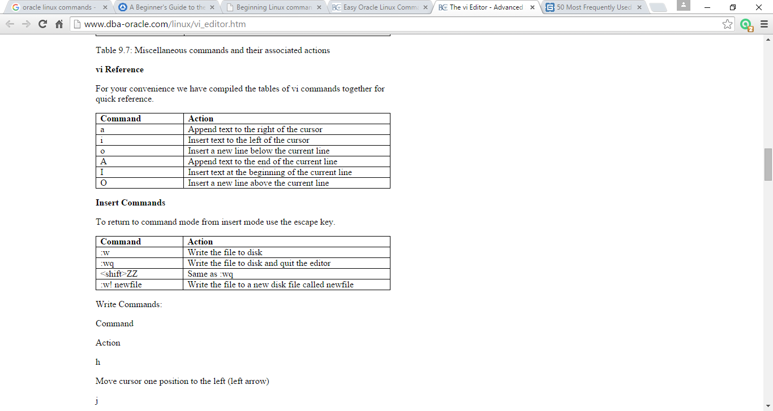

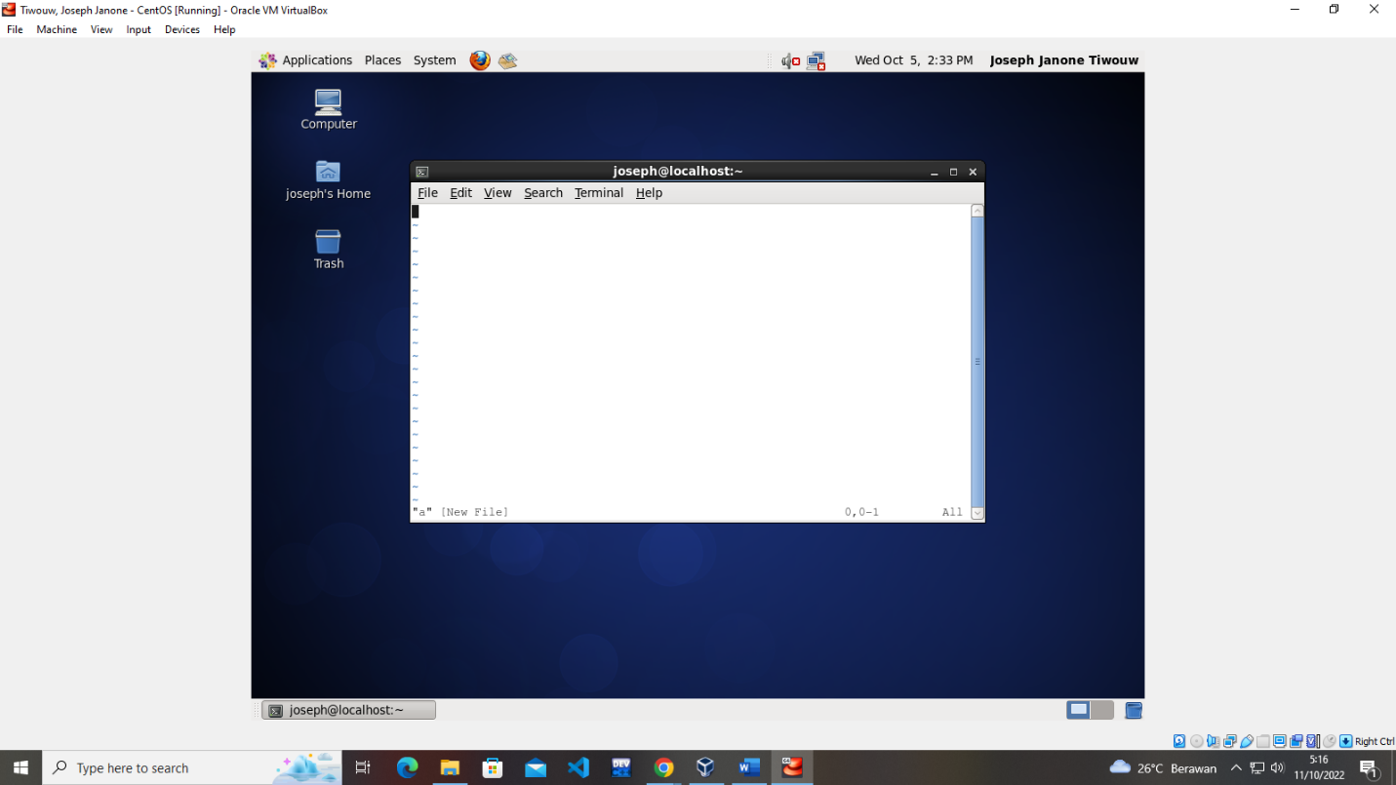

* uptime

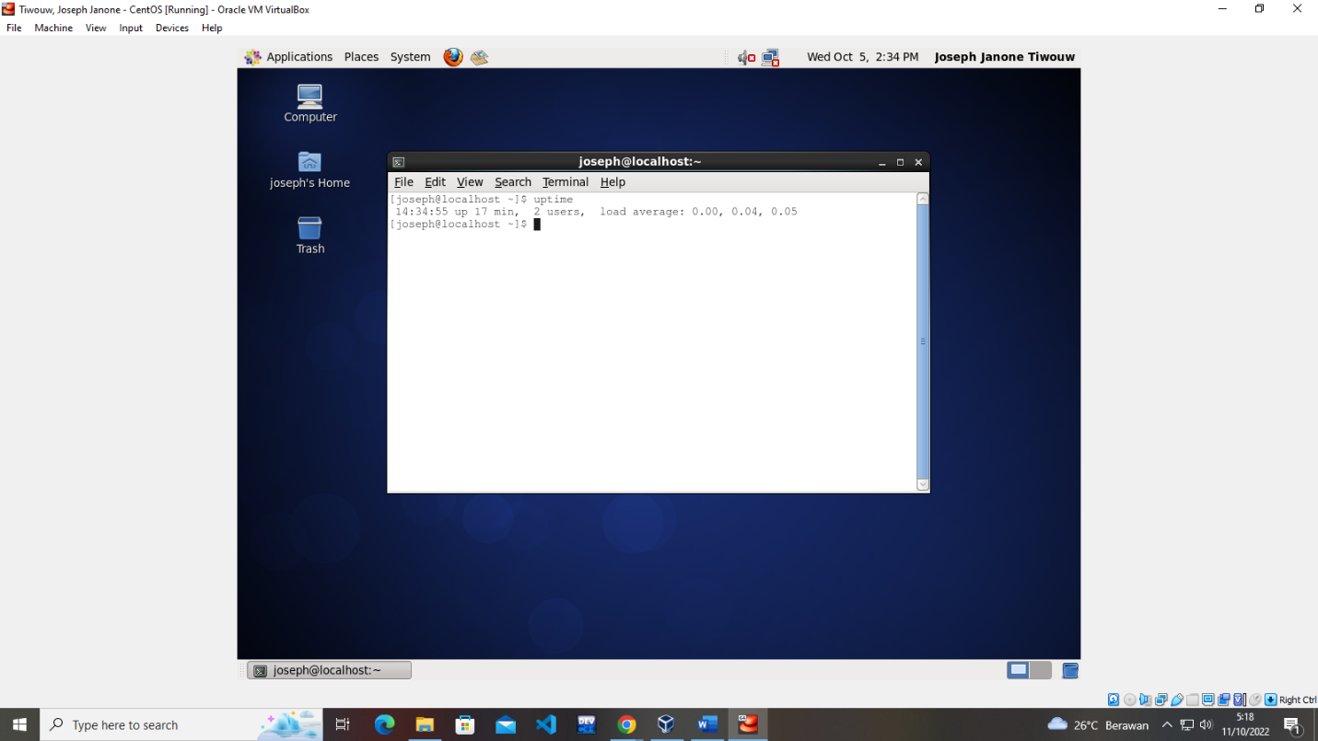

* who

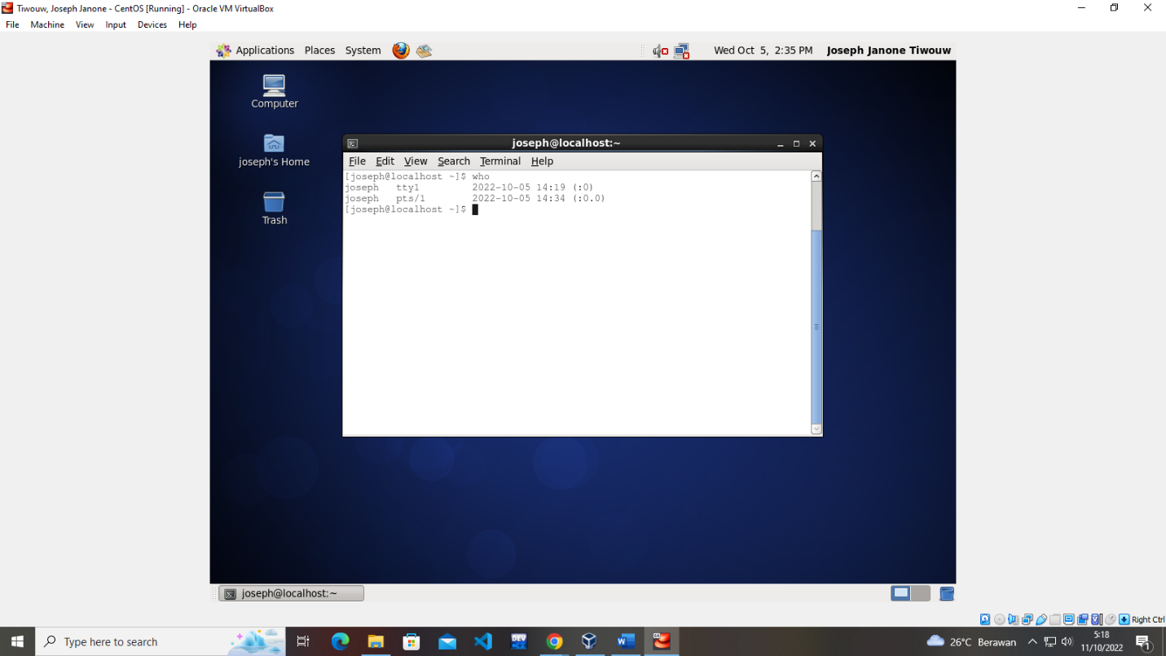

* whoami

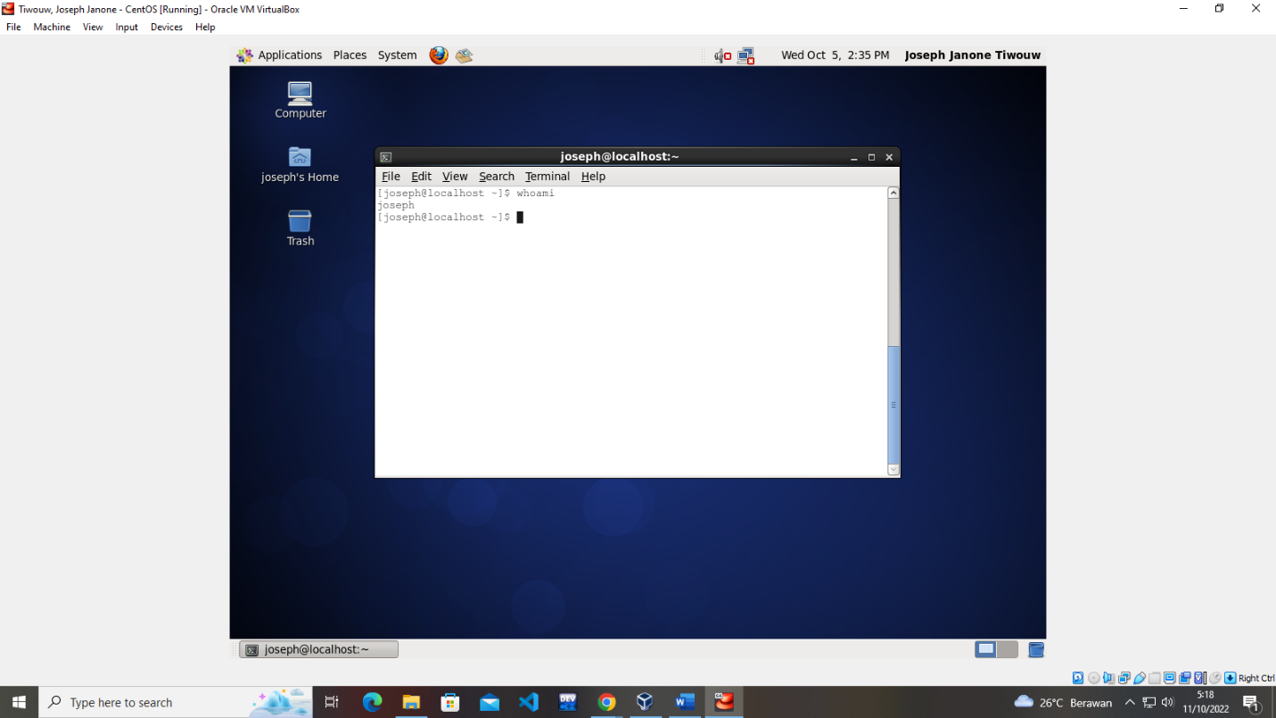

* chmod

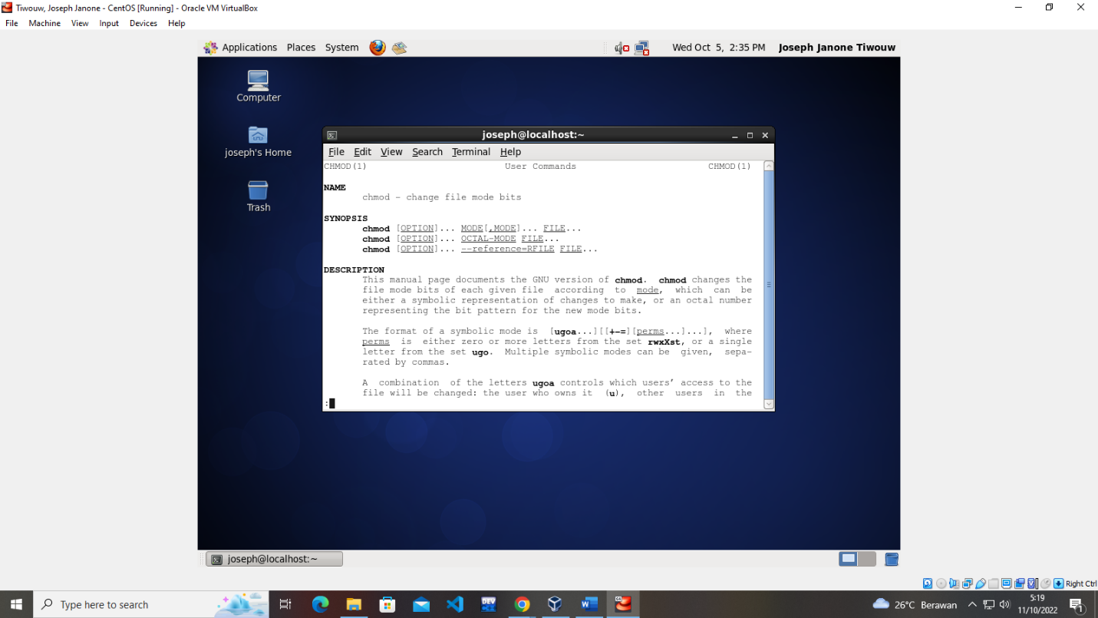

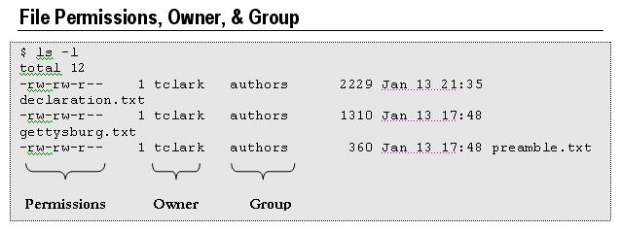

## File Permissions

File permissions are represented by positions two through ten of the ls ?l display. The nine character positions consist of three groups of three characters. Each three character group indicates read (r), write (w), and execute (x) permissions.

The three groups indicate permissions for the owner, group, and other users respectively.

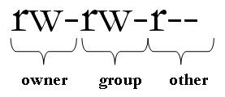

In the example above, both the owner and the group have read (r) and write (w) permissions for the file, while other users have only read (r) permission.

The example below indicates read, write, and execute (rwx) permissions for the owner, read and execute (r-x) permissions for the group, and no permissions for other users (?).

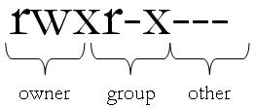

The alphabetic permission indicators are commonly assigned numeric values according to the scheme shown in the table below:

|  |  |  |
| --- | --- | --- |
| Alpha | Numeric | Permission |
| - | 0 | No permission granted |
| x | 1 | Execute permission granted |
| w | 2 | Write permission granted |
| r | 4 | Read permission granted |

Then, each three-character permission group can be assigned a number from zero to seven calculated by adding together the three individual numeric permissions granted. For example, if the owner has read, write, and execute permissions, the owner’s permissions can be represented by the single digit 7 (4+2+1). If the group has read and execute permissions, that can be represented by the single digit 5 (4+0+1). If other users have no permissions, that can be represented by the single digit 0 (0+0+0). These three numbers would then be listed in the order of owner, group, other, in this case 750 as a way to definitively describe the permissions on this file.

* History
* iostat
* write down 10 command that not listed on this module
  1. **Create, edit, delete file**
* Using “**touch** *filename.extention*”, example “**touch** *test.txt*” to create file

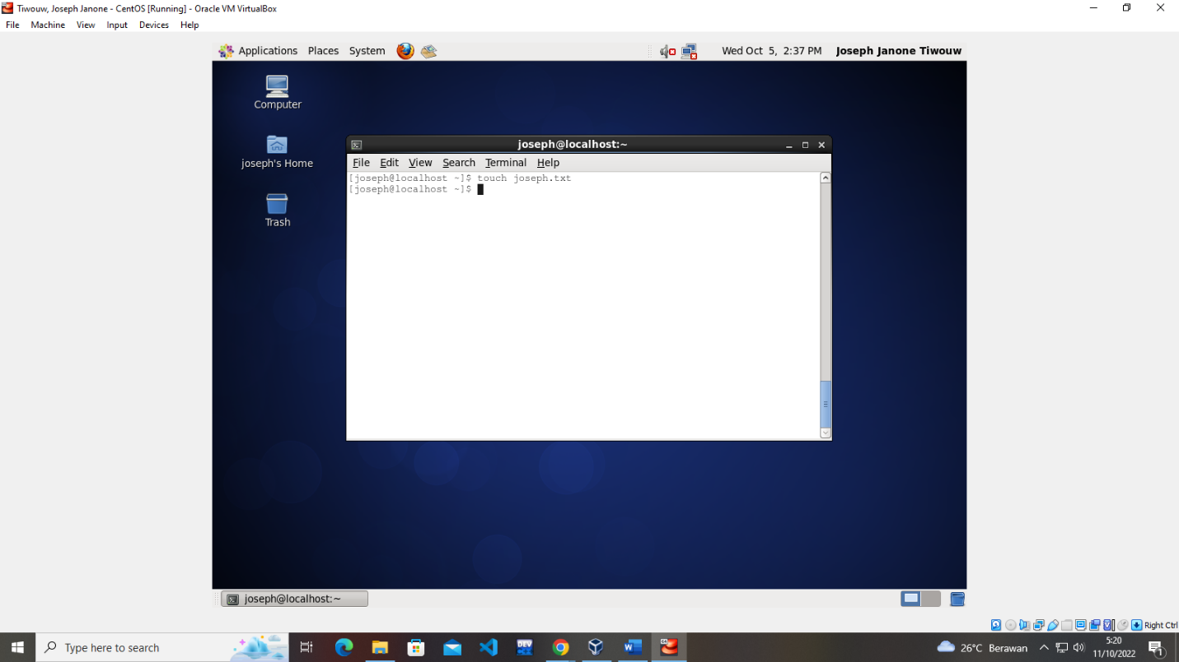

* Use **vi** command to to add/edit/delete the file content (see the list of command above)

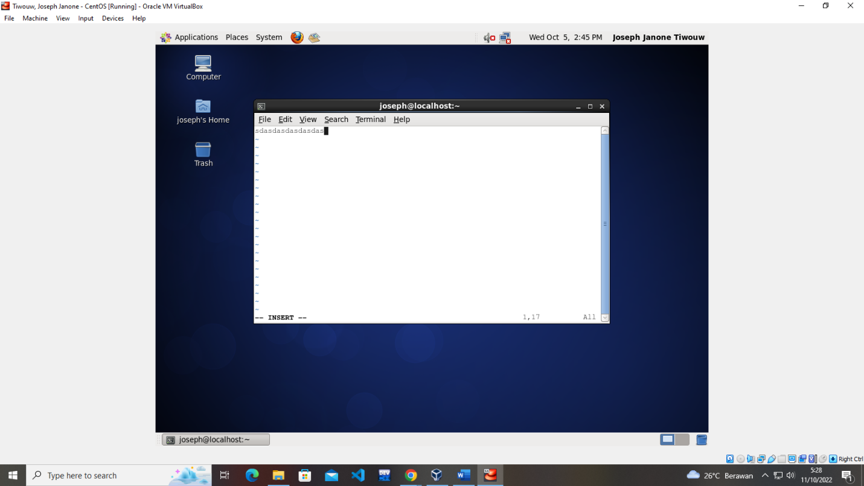

* Use “**rm** *[option] [filename.ext]*”

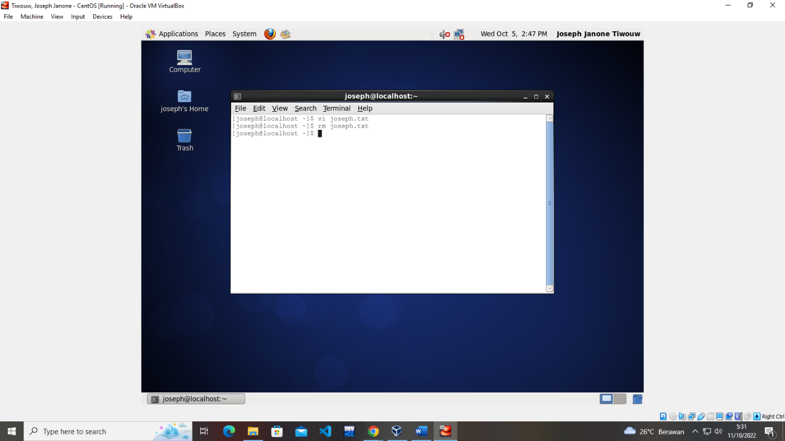

* 1. **Create, delete directory**

(see the list of command above)

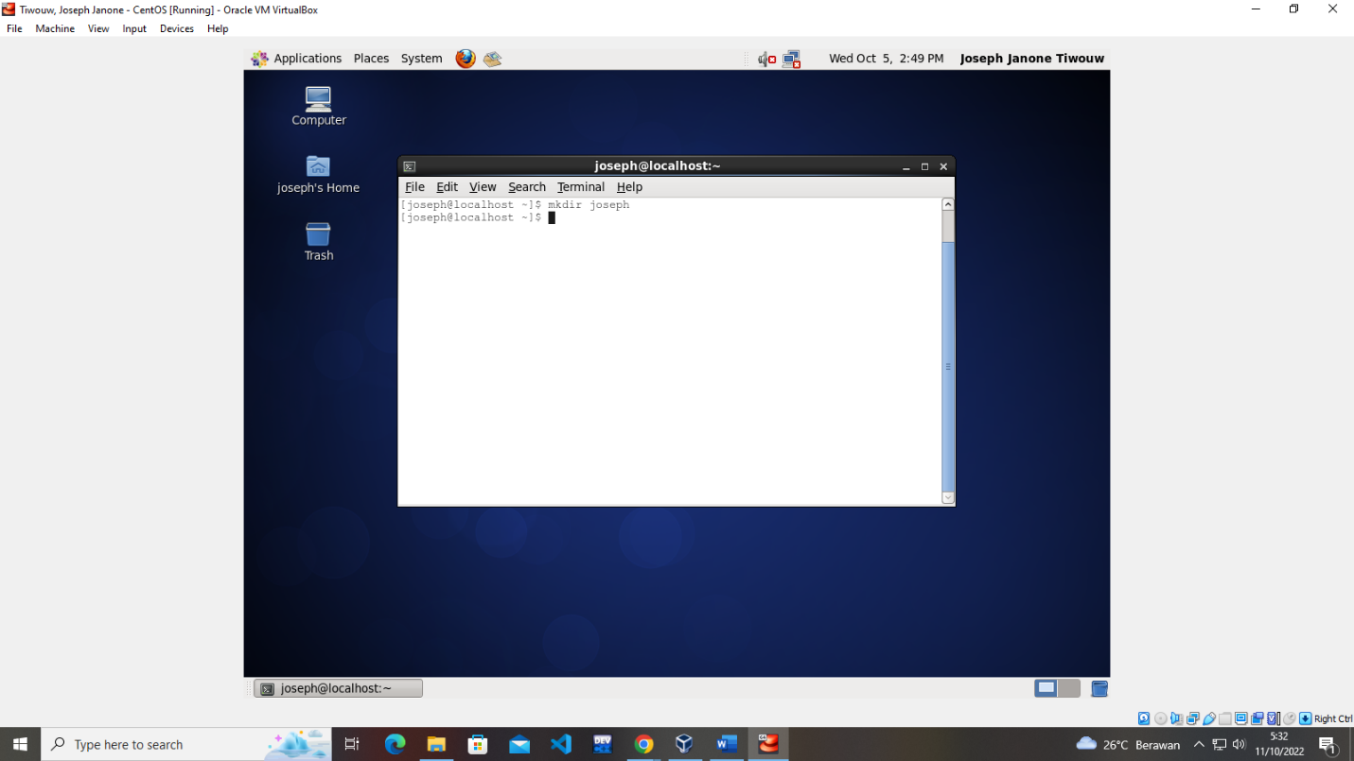

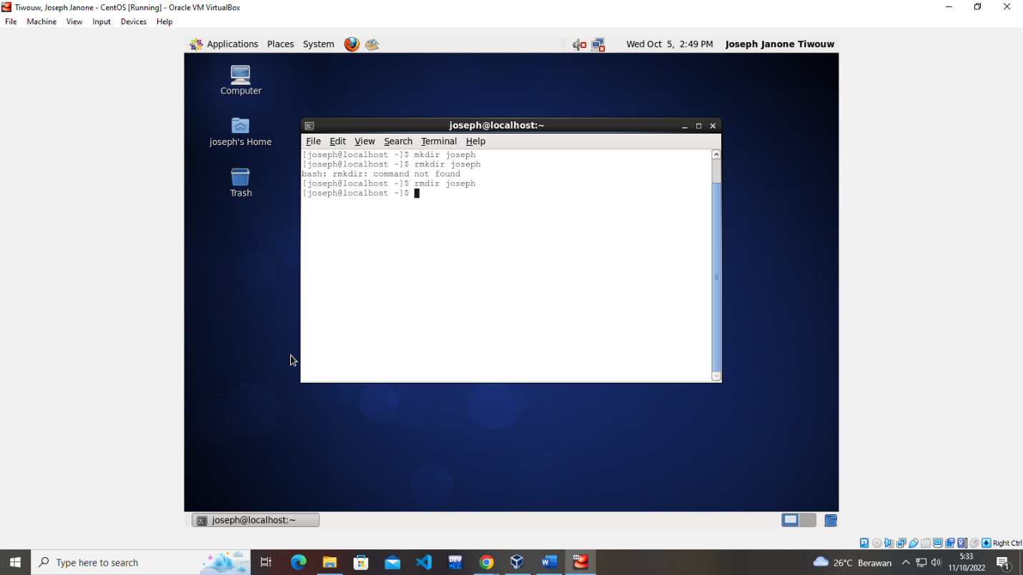

* 1. **SSH**
* Set your linux ip to 192.168.1.1
* 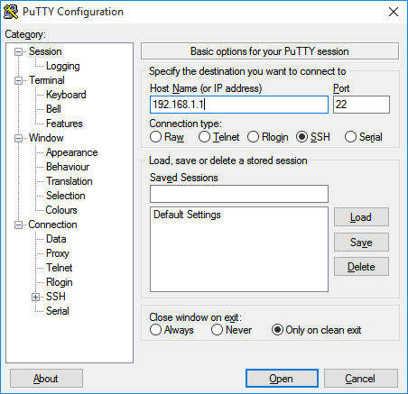Set your virtual box network setting so you can communicate with your host operating system or another laptop
* Open putty.exe application
* Input your linux ip
* Port for SSH -> 22
* Click open
* Voila…you can remote your linux now

**Autocomplete**

The magic key is “**tab**” to autocomplete your Linux command

